QConBridge Version 1.0

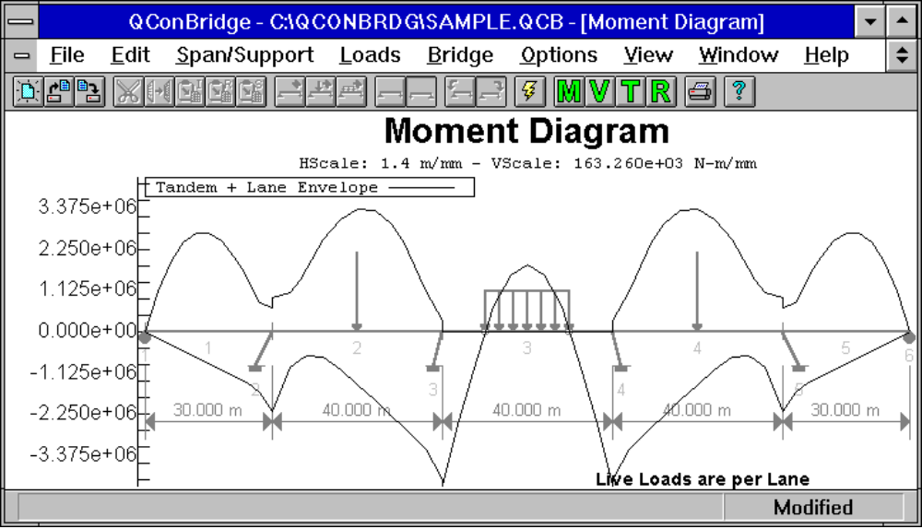

Features
- Supports the AASHTO LRFD Bridge Design Specifications, First Edition
- Use SI or English units interchangeably
- Virtually any bridge section and geometry can be modeled
- Integrated Section Properties Calculator to compute section and material properties, as well as live load distribution factors
- The Bridge Contractor will help you build a bridge model to your specifications
- Interactive model editing including Cut, Copy, and Paste features
- Model non-prismatic spans
- Model in-span hinges
- Model cantilever spans
- Build 2D bridge frame models, not just 1D beams
- Supports DC and DW load cases with built-in and user defined loads
- Supports HL93 notional live load model, including the optional dual tandem truck train
- Supports pedestrian live load
- Load combinations for Strength I, Service I, Service II, Service III, and Fatigue Limit States
- Customizable shear and moment diagrams
- User defined plotting styles
- Detailed reporting
- Context sensitive help
- 32bit program for Windows 3.1, Windows NT, and Windows 95

